**User Manual**

**jWebSocket**

**Python client library**

**1.0**

# Solution Characteristics

# The Python Client Library enables communication between client and server jWebSocket this being responsible for managing the connection and transfer files between them. The information travels over the two-way communication protocol WebSocket achieving greater application performance.

# Key Features

The Python Client Library provides the following functionality:

1. Start and End the connection to the server jWebSocket.
2. Send and receive information with the server jWebSocket.

Any developer or institution that implements in Python and want to develop desktop applications using the framework of jWebSocket can use the library as it is very easy to use.

# Problems to be solved

|  |  |
| --- | --- |
| **Problem** | **Contributions of the solution** |
| Improve productivity and reliability of real-time applications with the Python programming language using the framework jWebSocket. | A Python Client Library has two customers a low level that can be used for any application with any framework and other high-level client to communicate with the framework jWebsocket. |

# Glossary

* **Real-time Web:** is possible when the client receives messages from the server without prior request and end users to receive updates at the same time.
* **WebSocket:** Technology that provides a bidirectional and full-duplex communication channel over a single TCP socket. This protocol solves the limitations of HTTP, by establishing a full-duplex communication (TCP) between the client and server, replacing the half-duplex communication (HTTP).
* **Full-Duplex:** Quality of the elements that allow the input and output of data simultaneously.
* **jWebSocket:** is a new technology aimed at developing WebSockets based applications that provide high levels of speed, scalability, security and real-time work.
* **Client library:** It is group of programming interfaces used to develop client applications, the client libraries provide generic building blocks of distributed client applications.

# Solution Model

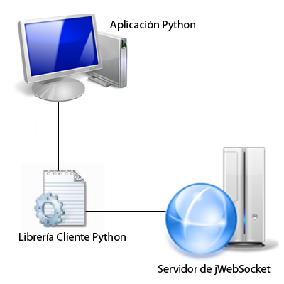

 The Python client library is responsible for communicating to the client application to server jWebSocket.

# Requirements for Use

 For proper operation of the Client Library have installed Python than 2.5.

# Main Roles

System User: You can perform all actions that provides the client library.

# Configurations of the solution

 Python is a dynamic language and functional unlike java and other languages ​​with only a few lines can solve an infinite number of problems. This is one of the reasons that often make Python developers hate the configuration files and unreadable. To develop this principle has been followed this rule, if a line can only change the world needed to Python XML or YAML 1000.